7 VEGETABLE CUTS EVERY COOK SHOULD MASTER
Posted by Chef Greg Eisele | August 9, 2016

“Show me seven perfect, unique cuts and you’re our next Executive Chef.”
All that’s standing between you and the career you’ve dreamed about is a basket of assorted vegetables. Your performance during this skills test could be the difference between being sent to the kitchen and being sent home. So, how would you do?
If you’ve had very little to no culinary training, probably not very well. In fact, many people who have never experienced culinary school know only basic vegetable cuts, such as rough chopping, dicing, and slicing. How you cut a vegetable greatly affects a dish’s cooking time and its final outcome. In order to be more versatile in the kitchen, here are seven vegetable cuts you should master:

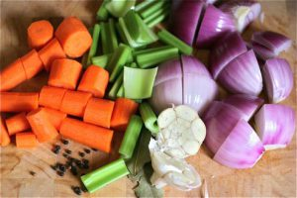1. Rough Chop
A rough chop is the most basic vegetable cut. It produces pieces that are “roughly” the size of a large dice (3/4 to 1 inch) without the precision. If a recipe does not specify how a vegetable is to be cut, chefs will use a rough chop to halve and quarter to make the pieces smaller. Onions, bell peppers, and squash are vegetables commonly rough chopped, especially when preparing kabobs and stir fries.

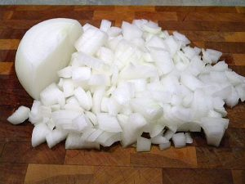2. Dice
Dicing vegetables helps food cook more quickly and looks more. A dice is a cube cut made by slicing a vegetable vertically and horizontally to achieve a checkered pattern.
- A large dice produces pieces measuring about 3/4 inch.
- A medium dice produces pieces measuring about 1/2 inch.
- A small dice produces pieces measuring about 1/4 inch.
Most recipes that call for vegetables usually ask for them to be diced; potatoes, tomatoes, onions, and bell peppers are among the most common.

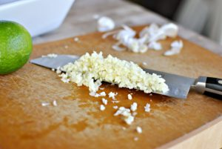3. Mince
A mince is essentially a very fine chop that when performed on a vegetable (e.g., garlic) will resemble a coarse paste. Minced vegetables dissolve quickly and are perfect for cooking broths and sauces.

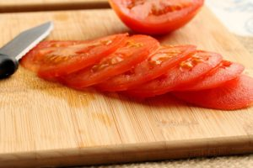4. Slice
Slicing a vegetable typically results in flat, round vegetable discs. This makes layering and stacking vegetables on top of each other easier, like when making pizza or lasagna. The thickness of the slice will vary depending on the recipe. For example, you’ll use a thin slice when making fresh potato chips and a thicker slice when making eggplant parmigiana.

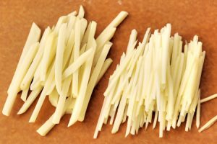5. Julienne
Often referred to as the “matchstick cut”, a julienne is used in recipes like coleslaw, spring rolls, and wraps when vegetables need to be thin and elongated. A julienne cut produces pieces measuring about 1/8 inch x 1/8 inch x 2 inches. A fine julienne cut produces pieces measuring 1/16 inch x 1/16 inch x 2 inches.

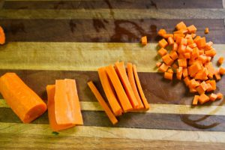6. Brunoise
The brunoise is essentially a julienne cut cubed. It produces pieces measuring 1/8 or 1/16 inch depending on the size of the julienne.

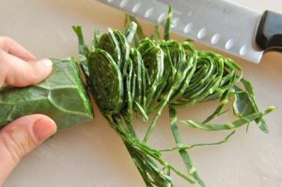7. Chiffonade
A chiffonade is most often used to slice leafy green vegetables or herbs that are to be stirred into a recipe or used as a garnish. To properly execute a chiffonade, neatly stack leaves that are roughly the same size roll the stack from stem to tip. Slice the roll lengthwise several times to create beautiful ribbons.

