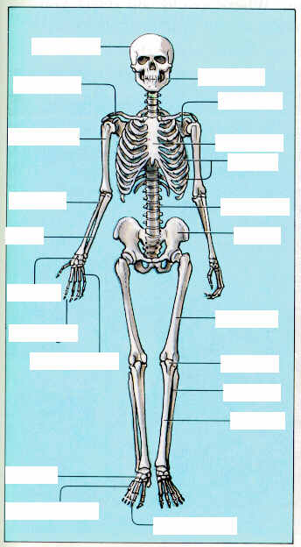

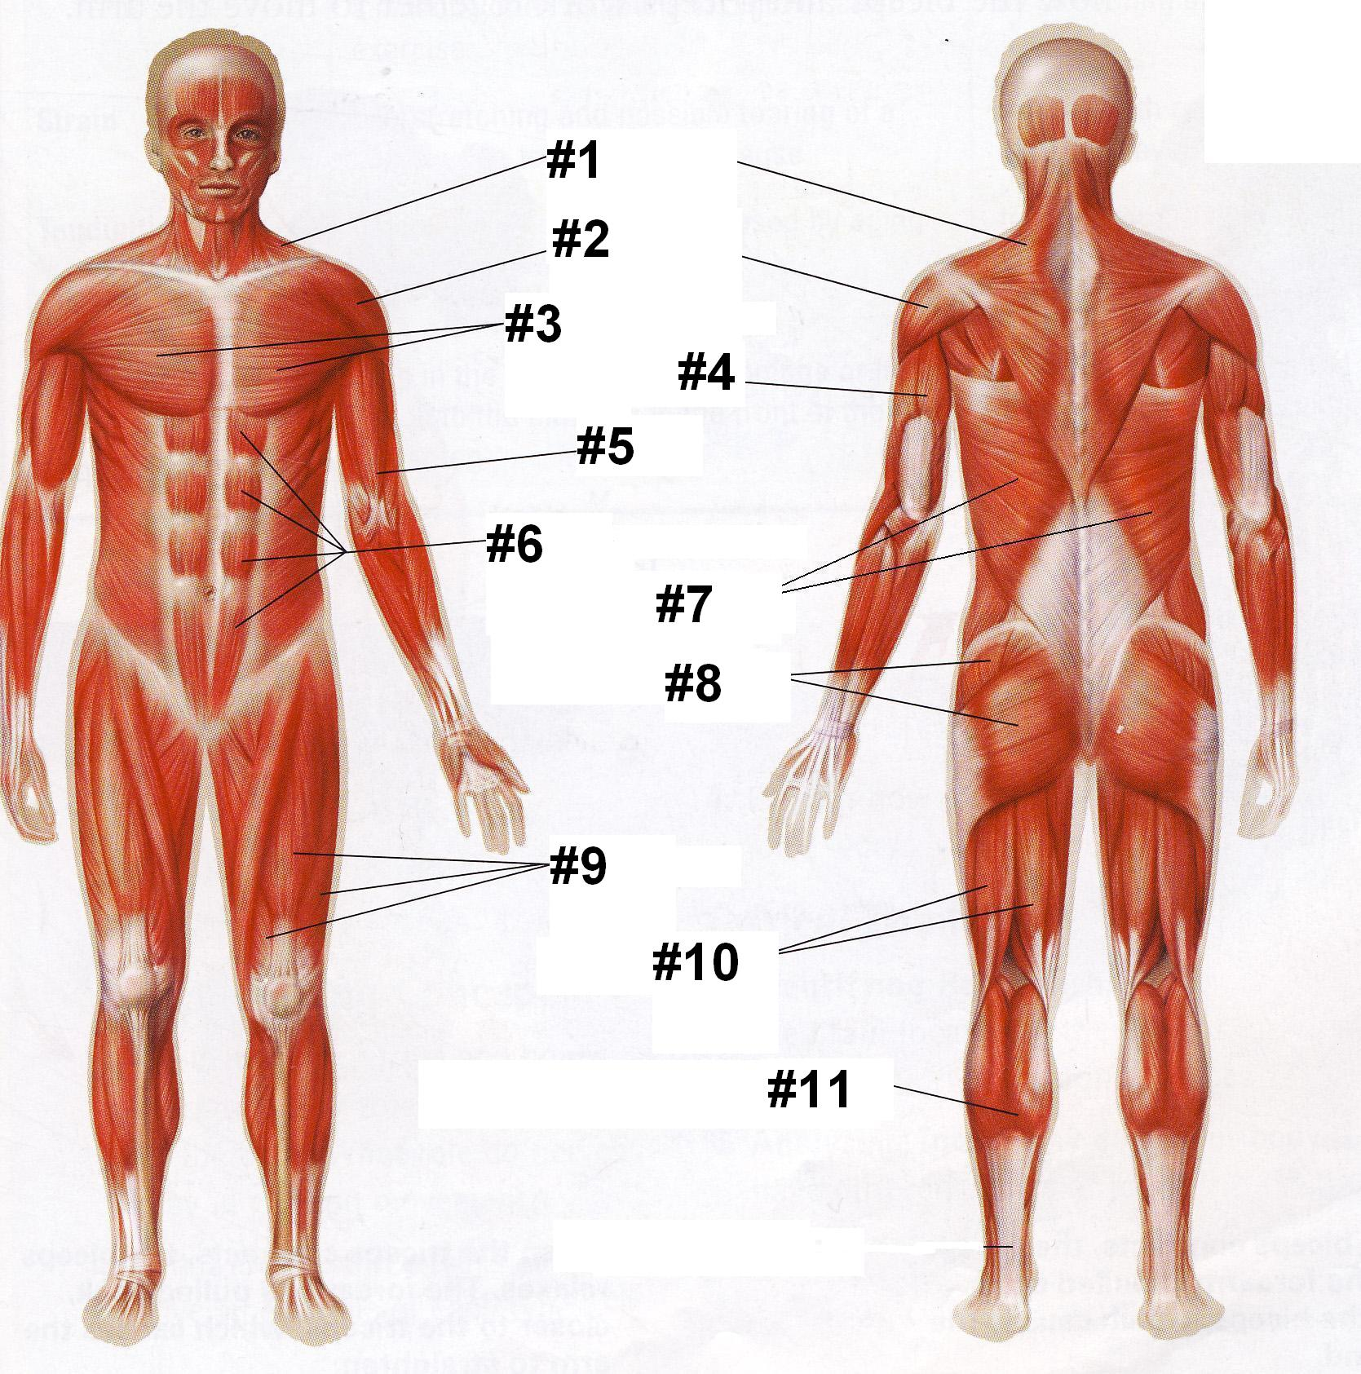
- 1.

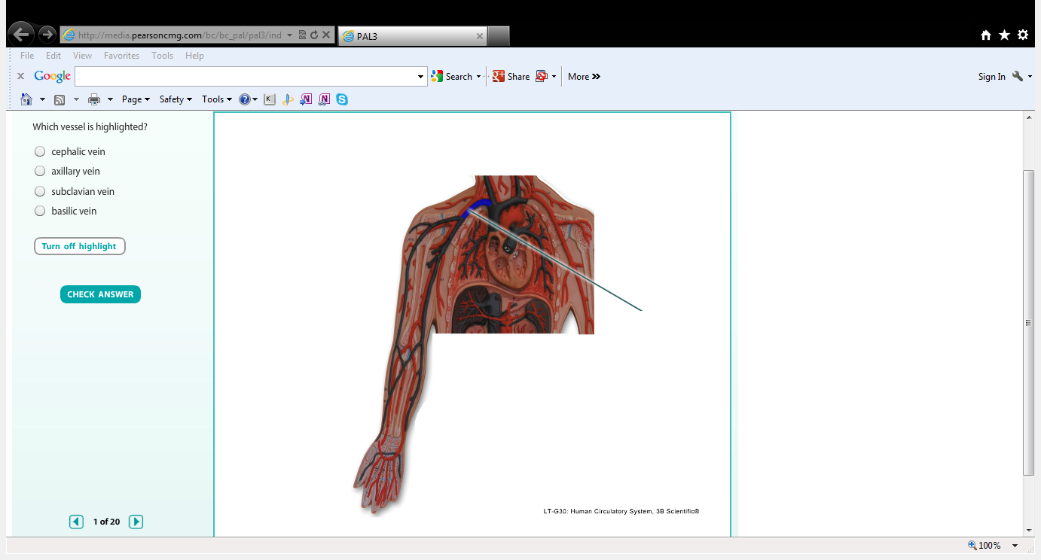
Which vessel is highlighted?
  - A.
Cephalic vein
  - B.
Axillary vein
  - C.
Subclavian vein
  - D.
Basilic vein
- 2.
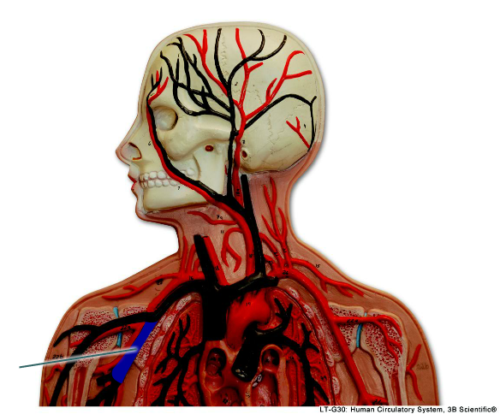
Which vessel is highlighted?
  - A.
Axillary vein
  - B.
Subclavian vein
  - C.
Cephalic vein
  - D.
Internal juglar vein
- 3.
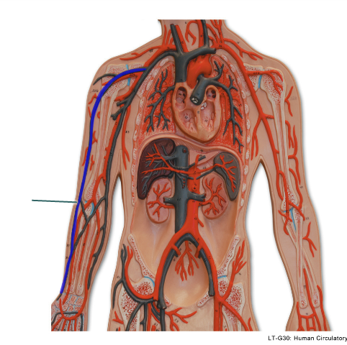
Which vessel is highlighted?
  - A.
Brachial vein
  - B.
External juglar vein
  - C.
Median cubital
  - D.
Basilic vein
- 4.
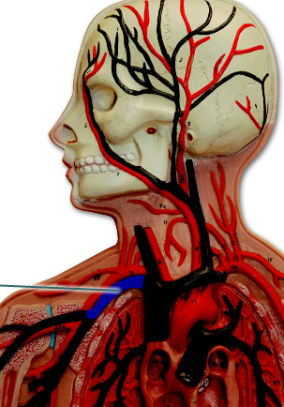
Which vessel is highlighted?
  - A.
Cephalic vein
  - B.
Basilic vein
  - C.
Subclavian vein
  - D.
Brachiocephalic vein
- 5.
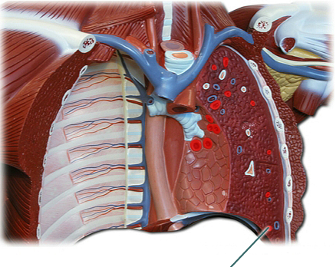
Which vessel is highlighted?
  - A.
Pulmonary artery
  - B.
Superior vena cava
  - C.
Inferior vena cava
  - D.
Pulmonary vein
- 6.
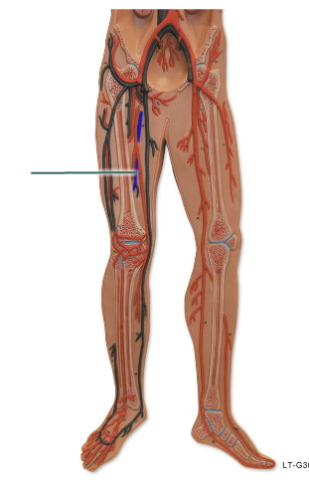
Which vessel is highlighted?
  - A.
External iliac
  - B.
Femoral vein
  - C.
Dorsal venous arch
  - D.
Great sapheneous vein
- 7.
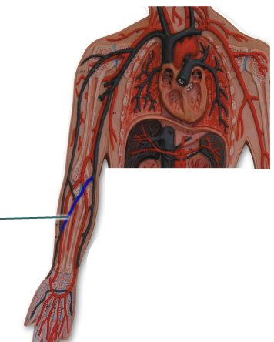
Which vessel is highlighted?
  - A.
Basilic vein
  - B.
Median cubital vein
  - C.
Subclavian vein
  - D.
Cephalic vein
- 8.
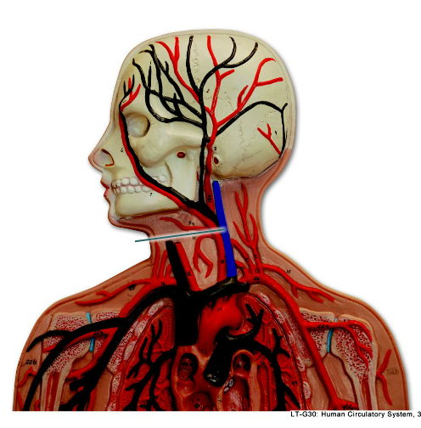
Which vessel is highlighted?
  - A.
Internal juglar vein
  - B.
External juglar vein
  - C.
Facial vein
  - D.
Subclavian vein

