FUNCTIONAL GROUP IDENTIFICATION WORKSHEET
- Identify the functional groups on the following organic molecules.

a.
H

b. H
H O

C C

H OH

O H H

C C

C C

H O H

H H H

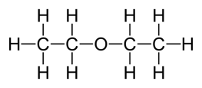
c.

- H
OH H H

H C C C C H

H H H H

- H H H

C C C C

Br H

H

H H H H

- Draw simple organic molecules that contain the following functional groups.
- Cycloalkane

- Amine

- Ether

- Ester

- Aldehyde

- Identify the functional group in each of the following molecules.

  - O

  - O

NH
  - O
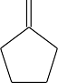
  - O O

Ph O Ph

e.

O

f. O

Br

- Draw simple molecules that contain the following functional groups. Draw as skeleton structures, as shown above – do not draw carbons, but only lines to represent bonds between them. Do not draw hydrogens if they are attached to a carbon atom.

  - Carboxylic Acid

  - Halide (Haloalkane)

  - Ester

  - Amine

  - Ketone

  - Aldehyde

  - Primary Thiol

  - Amide

  - Tertiary Alcohol

  - Secondary amine

