Liquids Written Homework

- Define Density.

- How is weight density different than the density you are most familiar with? Use your textbook to help you.

- Which is more dense, a cup of water or a sink full of water? Assume the water contains exactly the same minerals and came from the same tap.

- Which has the greatest pressure, a grapefruit sitting on the counter or one that has been cut in ½ and is laying on its cut facedown. You can mark it on the picture below and explain why.
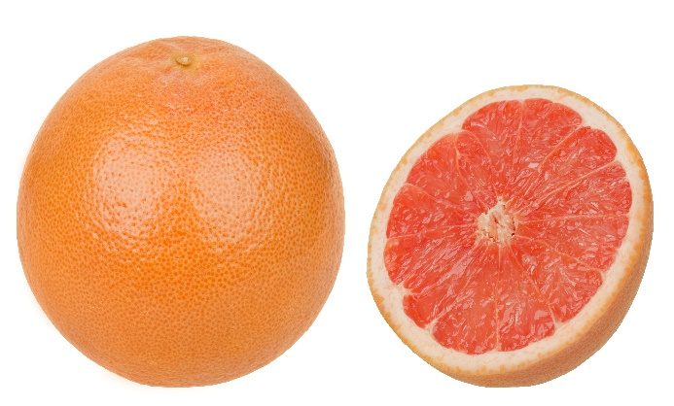

- Why can a person lay on a bed of nails and be hit with a hammer, yet not be pierced by the nails?
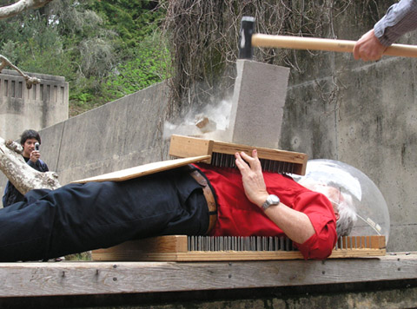

- What is the equation for pressure and what are the SI units?

- Write the equation for liquid pressure.

- What is a pascal equal to?

- If you hold a volleyball down below the surface of the water 1 meter deep, and the density of water is 1g/ml, what is the liquid pressure?

- If you hold a volleyball down below the surface of the water 2 meters deep, and the density of water is 1g/ml, what is the liquid pressure?

- If you hold a volleyball down below the surface of the water 10 meters deep, and the density of water is 1g/ml, what is the liquid pressure?

- This is something called Pascal’s vases. Which vase has the most liquid pressure and why?
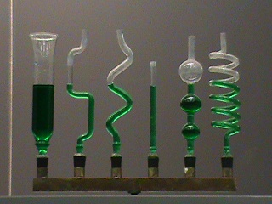
- Can you explode a wine keg? Mythbusters

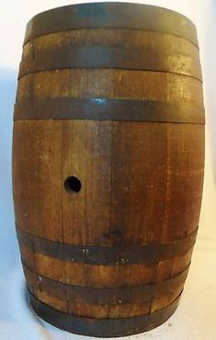

Assume the wine keg had a very long tube stuck in the hole, much longer than the one shown. In fact, it was so long a man had to climb up an orchard ladder and use a funnel to fill the keg and the tube to the top with water. Is it possible to explode the keg? Why or why not? Justify your answer and you might get credit even if you pick an answer that is opposite what really happens.

- Why is this dam constructed with this shape?

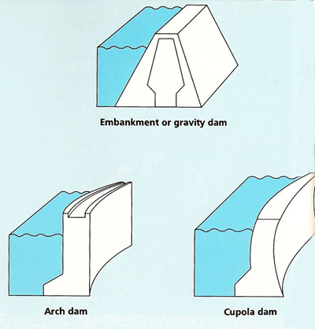

- Why would it be impossible for you to have varicose veins on your ears? It would be important to think about how pressure causes varicose veins in legs in order to answer correctly.

- Why does an object carried under water feel lighter to you?

- Remember that air is a fluid. Would an object carried in space with no atmosphere but with the same amount of gravity as we experience here on earth, feel lighter, the same or heavier to you?

- Draw a water column with 3 solid toy fish in it and equally spaced vertical intervals. Explain which fish experiences the most pressure and which experiences the most buoyant force.

- Look at the following scenario. If a dolphin is getting deeper and deeper, is the buoyant force the same at each place? You will have to look at density and decide if the density of the dolphin could possibly change to answer correctly. Remember the dolphin is made of flexible flesh, not solid plastic like the previous problem. Also the dolphin can swim much deeper than a plastic fish in a column of water would be found.

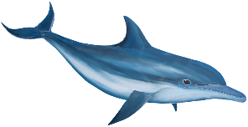

- You have 2 blocks of metal of identical size so that infers identical volume. One is green and one is blue. They displace identical volumes of water and those volumes of water they displace weigh the same amount. Which has the greatest buoyant force? Why?

- Consider the same scenario as before but one of the blocks is now made of Styrofoam. Which has the greater buoyant force on it?

- Why does something sink?

- Why does something float?

- Assume you had a block of clay. You drop it in the water and it sinks. You spread it out to make a boat and it floats. If it weighs the same in both cases, why does it float when you spread it out?

- What is Archimedes principle?

