Midterm Honors Biology Questions

- Medical Terminology practice – define these terms:
  - Liver
  - Gingiva
  - Head
  - Osteo
  - Organ
  - Kidney
  - Tongue
  - Bronchial
  - Bucca
  - Skin
  - Neck
  - Blepharo
  - Blood Vessel
  - Lung
  - Rhino
  - Muscle
  - Red
  - Blue
  - White
  - Cell
  - Hydro
  - Blood
  - Hyper
  - Brady
  - Tachy
  - Medial, Medi/o
  - Lateral, Later/o –
  - Superior, Super/o –
  - Inferior, Infer/o –
  - Proximal, Proxim/o –
  - Distal, Dist/o –

- Translate these sigs
  - i tab po TID and at HS
  - ii gtts OU q12h for glaucoma
  - dc acetaminophen stat.
  - Pt oob in am and npo p midnight
- Draw and label the following functional groups. Functional groups - amine, amide, arene, ketone, alcohol, ester, carboxylic acid, anhydride, aldehyde, ether, and thiol.

- Draw a stereoisomer molecule. Use Med chem homework Slide show 1 to help you.

5)What type of stereoisomers are typically found in living molecules?
6) Cell structure - attempt to label at least 12 structures and include a description of their function.
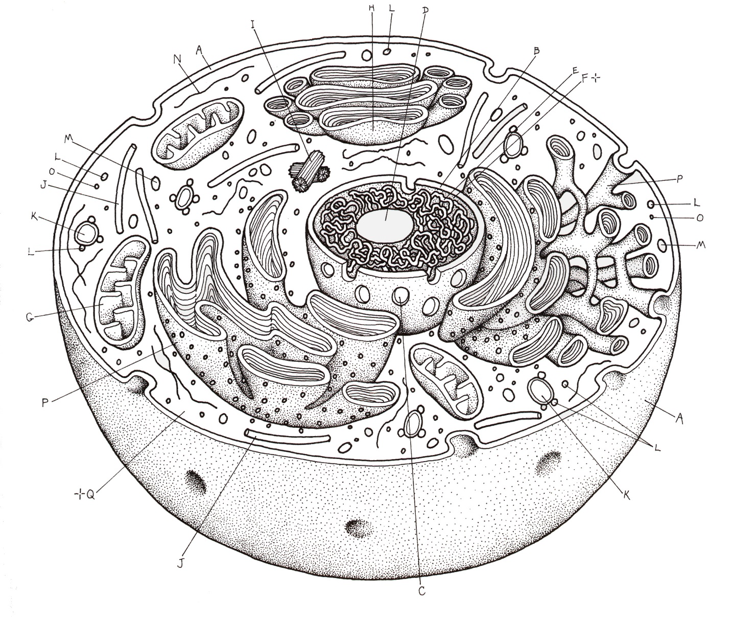

7) Describe in detail the process of DNA replication. Include drawings. Your answer must include 3 key enzymes.

8) Describe in detail the process of Transcription. What is its purpose and what does it accomplish? Drawings are required.

9) What is the purpose of translation? Draw an illustration of the process.

10) What are the 3 types of RNA and what are their functions?

11) What happen physically to a person taking heroin over time?

12) What happens physically to an alcoholic over time?

13) What happens physically to a methamphetamine addict over time?

14) What is a receptor for a drug?

15) There are 3 ways receptors bind drugs. Can you list those?

16) Make a list of 3 antibiotics, 3 analgesics, 3 gastrointestinal drugs, 3 antidepressants by looking up names on the internet. This is how we categorize them in order to understand their function more clearly.

17) What is haploid?
18) What is diploid?
19) What is heterozygous?
20) What does the term epigenetics mean?
21) Historically, what changes did the FDA make due to the thalidomide incident?

22) Draw what is happening during mitosis.
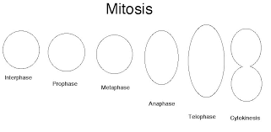

23) Describe the 3 stages of interphase, G1, S, G2.

24) Draw what is happening in meiosis. The diagram should help lead you through the process.

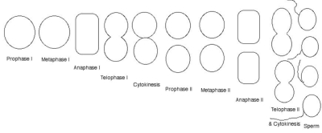

More to come. Please check back.

