Molecular Gastronomy Spherification practice

Molecules in Food

Spherification uses alginate, a carbohydrate polymer from alginate, to create a gel that encases a liquid. Alginate dissolves in water, so this technique works for most water-based recipes. Spherifying oils, like the olive oil requires a slightly more complicated procedure.
Below is one of the units of an alginate polyer:
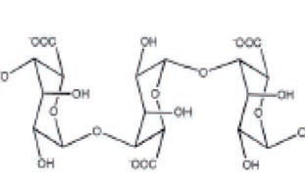

Phase Transitions

A shell of liquid around the drop forms a solid shell, a type of irreversible phase transition from liquid to solid.

Texture

The spheres become elastic because of the gelled shell.

Diffusion

The thickness of the shell depends on the length of time the drops are submerged in the alginate (or calcium) bath. This thickness roughly doubles for every factor of four increase in the time.
Below is a series of images showing the cross section of a single sphere over time, from Pere Castells: (This is French people) 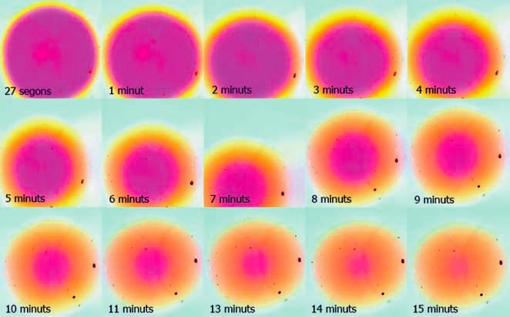

Chemical reactions

The calcium in the recipe links together the alginate polymer strands. The salts like sodium with 1 valence electron don't work since they bind to only one strand at a time. Remember they give up that one electron and become a cation with a +1 charge. One electron in the valence is called monovalent. That means they can bind one thing with a -1 charge. Calcium is divalent. It has 2 electrons in the valence shell so it can bind 2 things at once with it gives up those electrons and has a +2 charge. Therefore, it can bind to two strands simultaneously.

Calcium ions can bind together separate alginate strands forming a network
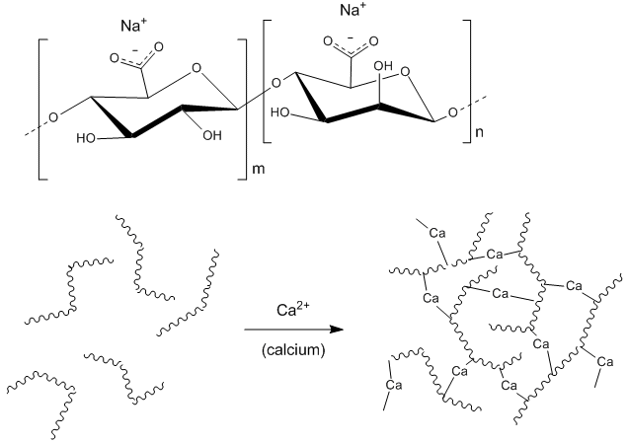
Gelation Questions

- What would happen if you made yogurt balls using direct spherification? How could you get around this problem?

- Which type of spherification should you use if you must store the spheres?

- Why does gelatin need to be heated before it can set? What about gellan?

- Methylcellulose gels when it's heated and melts as it cools. What might it be used for?

- Why is alginate used in spherification? Why not other gelling agents?

Flow

More viscous liquids are easier to spherify, since they can hold their shape better while the gel layer forms. Xanthan gum is sometimes added to make it easier for the liquid to form a sphere.

Activity 1: The molecular egg
https://www.youtube.com/watch?v=f8QGA4vN6HY - watch
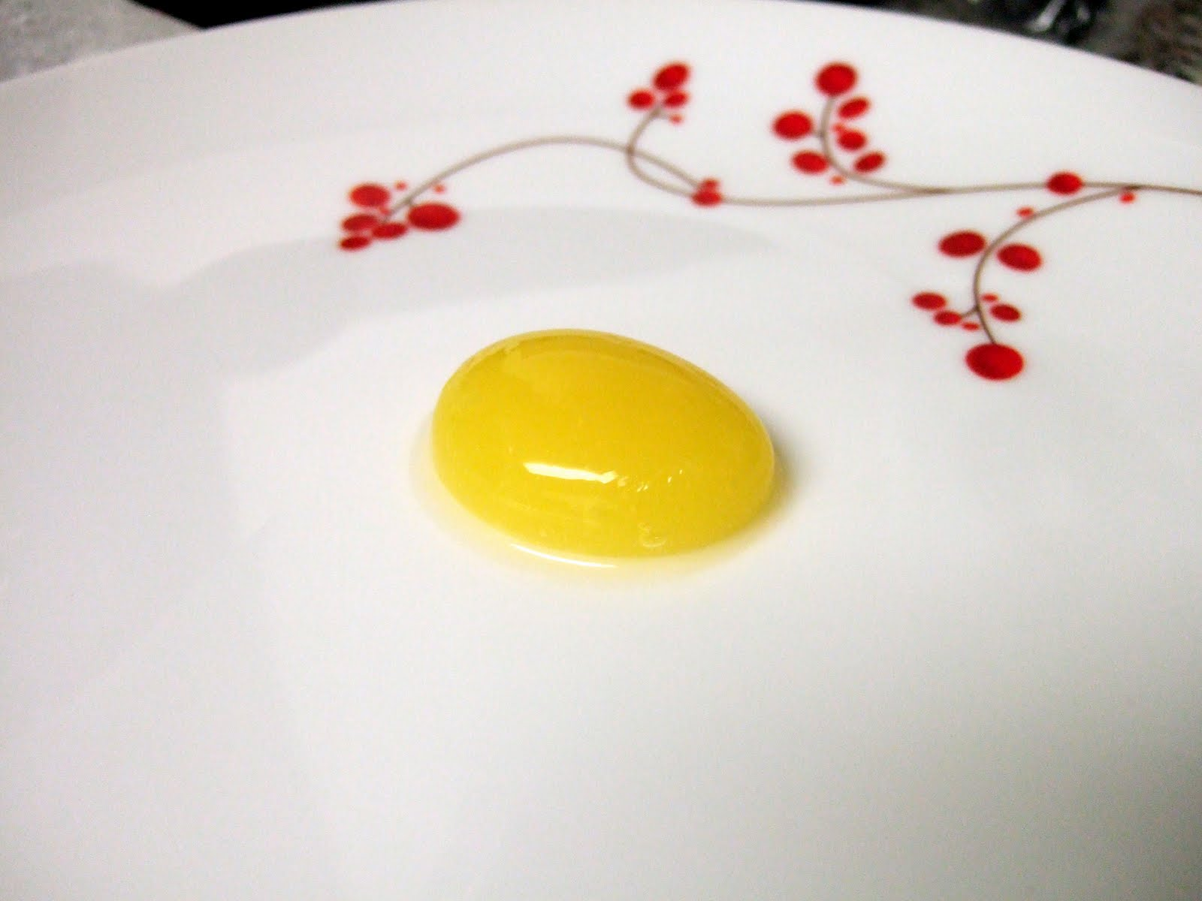
Step 1: Create a Sodium Alginate Bath 0.5g Sodium Alginate to 100g water. Mix with immersion blender.
Step 2: Mix a ½ cup milk in a saucepan with 1 packet of agar agar. Stir constantly on low heat and bring to a boil.
Step 3: Pour into a glass measuring cup containing 2/3 cup vanilla yogurt. Stir well.
Step 4: Pour onto a plate in a thin layer representing the white of the egg. Let it set for 15 min. Pour another smaller layer and let it set up.
Step 5: In a blender, pour in 1 – 1.25 cups of mango, add in 2 Tbsp of sugar,
and add ½ tsp of calcium lactate and puree it until smooth.
Step 6: Use a round Tbsp to VERY GENTLY form a sphere of mango in the sodium alginate bath. Let it sit for 1 min.
Step 7: very gently take the sphere out of the bath and rinse it in a clear water bath.
Step 8: Place it on the egg white to make it appear as if it were a real egg.

Activity 2: Honey Caviar
https://www.youtube.com/watch?v=kOsZPrw2ULI – Watch

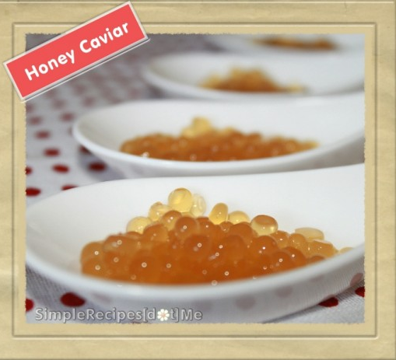

Step 1: Set a glass of vegetable oil in the fridge for 30 min.
Step 2: In a sauce pan, place 1/3 cup of water, ½ cup of honey, and 1 packet of agar agar.
Step 3: Stir and bring to a boil.
Step 4: Draw this up into a syringe and drop it bit by bit into the oil bath. Allow it to sit for 1-2 min while continuing to add more droplets.
Step 5: Scoop the pearls out with a spoon and add them to a clear water rinse bath.
Step 6: Stir the bath gently until you get the pearls to separate and any left over oil to rise to the top.
Step 7: Taste on milk and honey crackers.

