Momentum In-Class Experiences
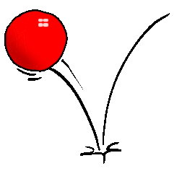

1) Thomas trains – when two trains collide, does the momentum of the system increase, decrease, or stay the same?

2) Play with the bouncy balls. How is momentum transferred?

3) What is conservation of momentum?

4) Human dynamics carts – how is momentum conserved here?

