First and Last Name ________________________________________________ Date _____________________
Spring Quiz 6 SEEDS and Reptiles Junior Life Science 10 points Teacher Mrs. G
SEEDS
- Some seeds you can eat and some you can’t. _____ True or False
- The structure of a seed has 3 parts: Seed Coat, Embryo, Cotyledon. ______ True or False
- The outer covering of a seed is called a ___________________________________________________.
- The baby plant inside the seed is call an _________________________________________________.
- The part of the seed that will be the food that the baby plant will use to grow is called ___________________.
How a seed becomes a plant – WATER makes the seed swell up and split open, the radicle comes out and turns into the roots, the plumule comes out of the seed and grows up. The cotyledon is exposed. The cotyledon feeds the baby plant until the cotelydon is all gone. The plant now has a stem, roots and leaves. It is called a seedling.
- Germination takes place when there is water, oxygen, warmth and sunlight. _______ True or False
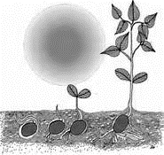
- Seed Dispersal means the scattering of seeds over long distances. _____________ True or False
- Agents of seed dispersal are Wind, Water, Animals and Humans. ________ True or False
- Do some seeds explode out from the plants? ____________________ Yes or No
- Coconuts are big seeds that can float _______ Yes or No
- Animals eat fruit and poop out the seeds. ____ Yes or no
- Some seeds stick to animal’s fur. ________True or False
- Not all plants have seeds. ______________ True or False
- Pizza grows on trees? _______ Yes or No
- Name some agents of seed dispersal. ___________________________________________________________________________________________
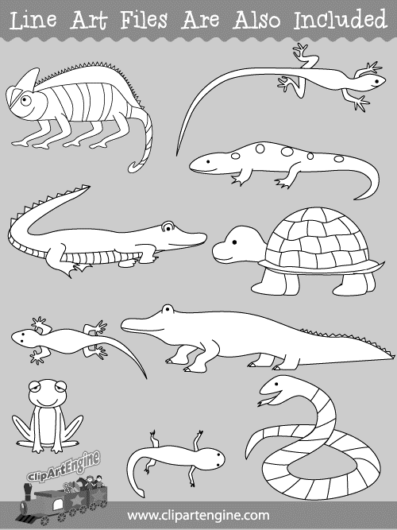
Reptiles are vertebrates
- Reptiles have dry, waterproof scales. _____________ True or False
- Reptiles have feathers. ___________ True or False
- Some reptiles have boney plates too. ________ True or False
- Reptiles breath in oxygen just like people. ________ True or False
- Reptiles are _______________ blooded.
- Cold-blooded means that the animals cannot warm themselves up __ True or False
- What is your favorite reptile? _______________________________________
Draw your favorite reptile.

- Reptiles are oviparous (lay eggs). __________________________ True or False
- Most reptiles are carnivores which means they eat ________________________.
- Reptiles drag their stomachs on the ground or near the ground. ____________ True or False

