First and last name:____________________________________ Date:_____
SPRING Quiz 3 Junior Life Science – Flower Dissection and Amphibians - Frogs 10 Points - Teacher – Mrs. G
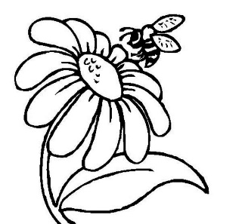
Flowers from https://www.reference.com/science/function-flower-7318f360896ebbee#- The purpose of a flower is to attract pollinators to a plant to aid in fertilization so that the plant creates seeds. Bright colors, strong scents and sweet nectar all work together to attract birds, bees and other insects to move pollen from one flower to another. After pollination occurs, the flower develops seeds. Flowers are an important part of the reproductive system of plants. Each flower produces pollen, which is released through the anther part of the stamen. Some flowers produce pollen that is carried by the wind to other flowers so that fertilization takes place. Many flowers require a pollinator to carry the pollen. Common pollinators include hummingbirds, bees, wasps, ants, flies and beetles. In some parts of the world, small mammals and lizards also function as pollinators.
The particular color, pattern or scent of a flower attracts the appropriate pollinators. Pollinators feed on the nectar produced by the flower. During feeding, pollen, which is sticky, adheres to the pollinator's body. When the pollinator feeds at a different flower, the pollen moves from the body through the flower's stigma into the ovary where fertilization occurs. At this point, the flower has served its purpose. As the seed develops, the ovary grows into a fruit and the flower withers.
- The purpose of a flower is to _______________________ pollinators.
- The POLLINATORS carry pollen from flower to flower to aid in _____________________.
- Once a POLLINATOR leaves pollen at another flower seeds can form. ____ True or False
- Once the flower is pollinated and the flower withers the ovary grows into a ____________.
- Name 3 pollinators: _______________________________________________________.

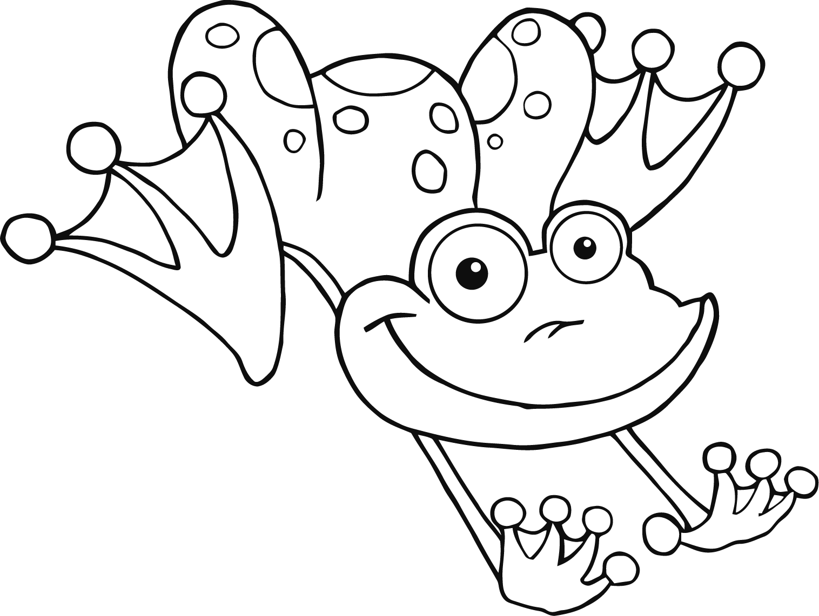
FROGS are AMPHIBIANS from - http://www.kidzone.ws/lw/frogs/facts3.htm The word amphibian means two-lives. Amphibians spend their lives in the water and on land. All amphibians begin their life in water with gills and tails. As they grow, they develop lungs and legs for their life on land. Amphibians are cold-blooded, which means that they are the same temperature as the air or water around them. All amphibians lay eggs. There are more than 4,000 different kinds of amphibians. Members of this animal class are frogs, toads, salamanders, newts, and caecilians or blindworms.
FROG Life Cycle - Metamorphosis is the change of shape during an animal’s life. During metamorphosis the tadpole will develop back legs first, then front legs. Around 6 weeks of life the mouth starts to widen. Sometime around 10 weeks the froglet’s, as it is now called, eyes start to bulge out and the tail begins to shrink and eventually disappear. When the lungs finish developing the froglet makes it’s way onto the land and, Ta-da! It’s a frog!
- Frogs are _____________________.
- All amphibians begin their life in water with ____________ and _________________.
- There are _____________________ types of amphibians.
- _____________________ is the change of shape during an animals life.
- Tadpoles will develop back legs and then front legs. ________ True or false
- A tadpole turns into a froglet after how many weeks? _________
- When the ________________ finish developing the froglet becomes a frog.
- What are the 5 classifications of vertebrates? (remember F A R M B)
__________________________________________________________________________________________________________________________________________________________
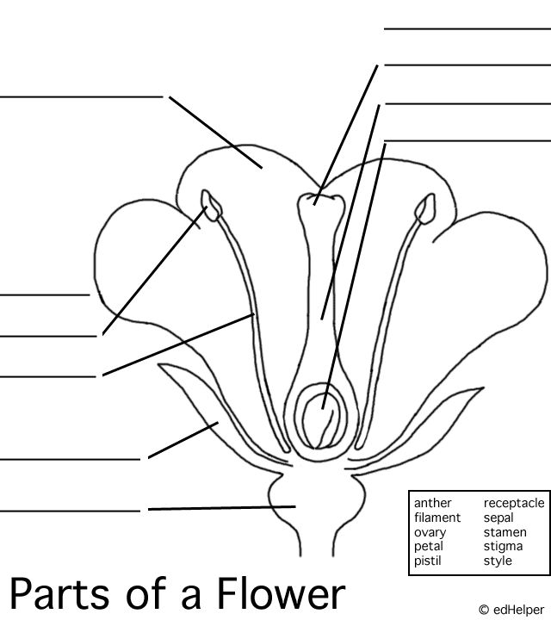
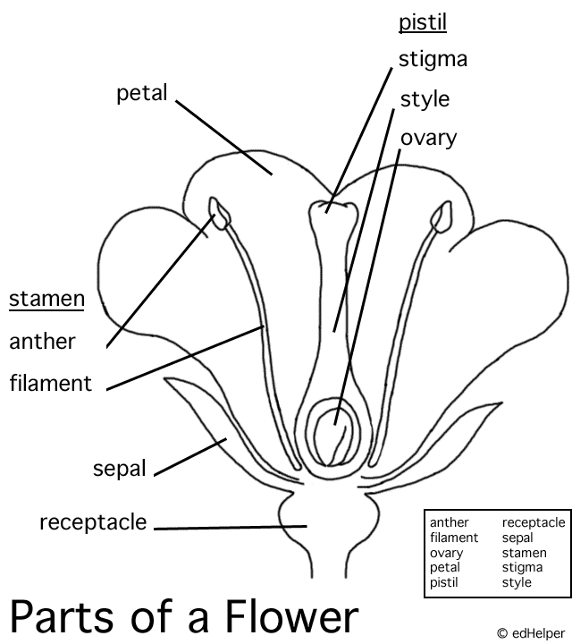
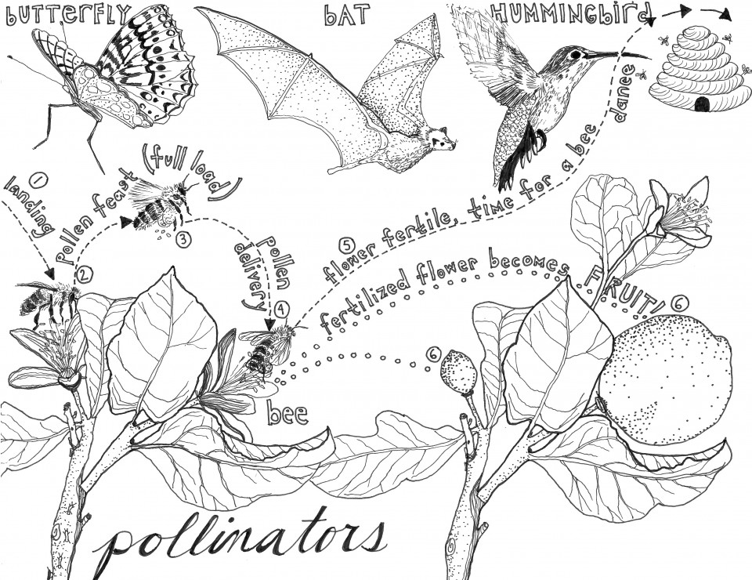
http://freecoloringpages.co.uk/ages.co.uk/

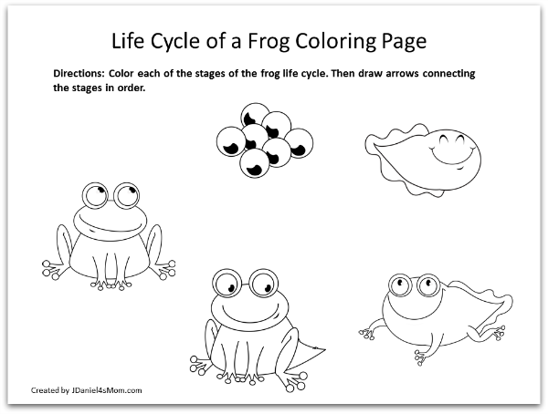
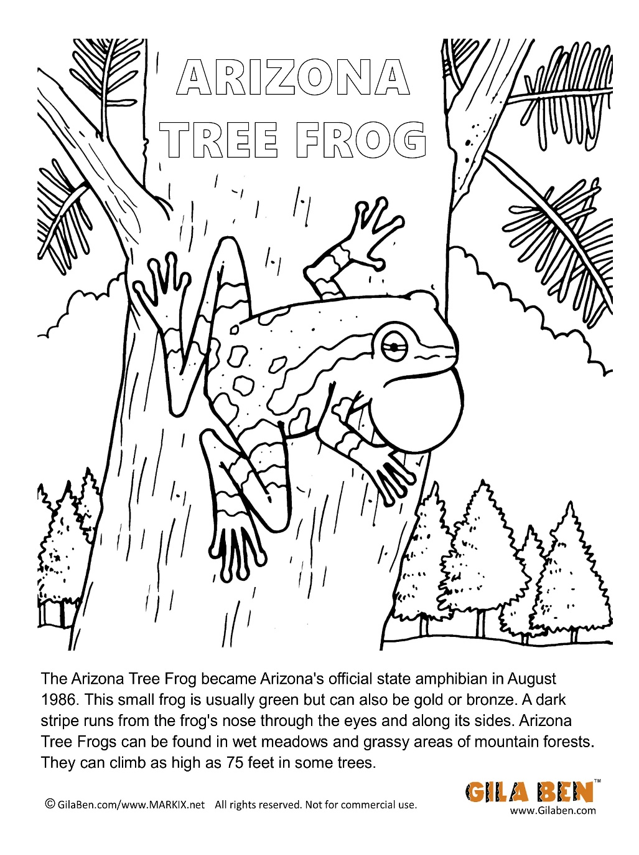
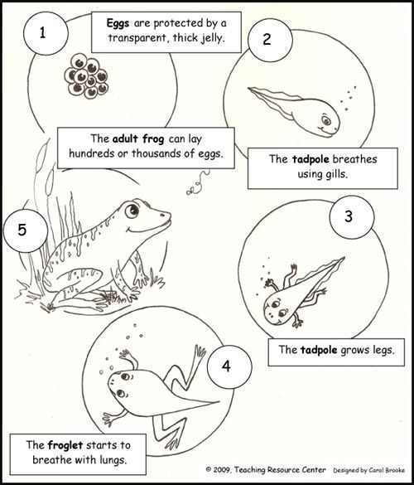
State Amphibian: Arizona Tree Frog
State Bird: Cactus Wren
State Gemstone: Turquoise
State Fish: Apache Trout
State Flower: Saguaro Cactus Blossom
State Fossil: Petrified Wood
State Mammal: Ringtail
State Reptile: Ridge-nosed Rattlesnake
State Tree: Palo Verde
Arizona Character

