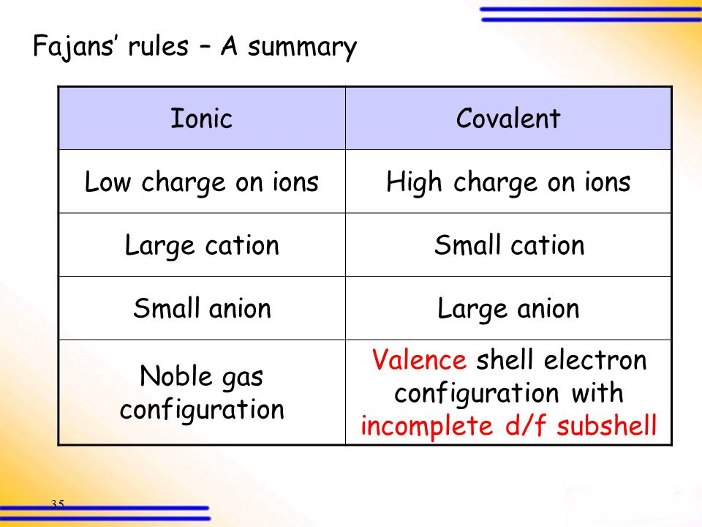

- The purpose of Fajan’s rules is to describe the ionic character or the covalent character of a bond. Although we imagine perfect ionic bonds with 2 ions completely separate, and perfect covalent bonds with atoms equally sharing electrons, the reality is they are somewhere in between.

COVALENT CHARACTER
- Case 1 – small cation, larger anion. The larger anions outer electrons are able to be pulled away and distorted by the cation more easily because they are further from the nucleus and held less tightly. This results in covalent character in that bond.
Case 2 - In the case of similar size cation and anion in general, if an atom has incomplete d or f subshells that could hold more electrons, the bond will act as if it has covalent character because the cation will be able to pull the electron in the anion towards itself, creating covalent character.
Case 3 – In the case of similar size large cations and anions, the cation has given away electrons to become a cation and therefore the underlying noble gas configuration is displayed. That configuration doesn’t distort much but the outer layer of the anion will.
Case 4 – In the case of a high charge on EITHER the cation or anion or both, the ability to distort the electron cloud becomes greater and the covalent character increases.

IONIC CHARACTER
- Case 1 – Large cation, small anion. The smaller anions are closer to the nucleus and held more tightly in place. They are less likely to have their electron clouds distorted. This leads to more separation and more ionic character.

Case 2 – in the case of a similar size cation and anion and both are small, they are likely to have more ionic character because the electrons of each are closer to the nucleus, held more tightly in place, and less likely to be pulled into a distorted shape.

Case 3 – in the case of a low charge on either the cation on the anion or both, the low charge are less likely to distort the electron cloud and so they behave more ionically.

