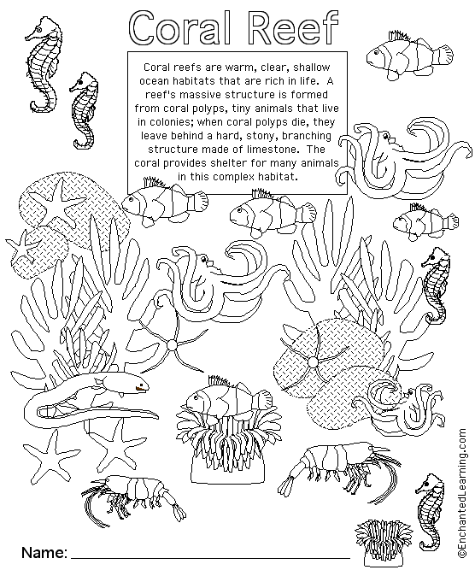

Find the **A**rthropods**, M**ollusks**, C**nidaria, **E**chinoderms and **V**ertebrate animals.

Label them with a small - A, M, C, E or V.

Do your best coloring on this page.